Thực hành Kiến trúc máy tính tuần 4

Họ và tên: Nguyễn Khắc Hiếu

MSSV: 20225839

Assignment 1

* $s1 = 16, $s2 = 3:

#Laboratory Exercise 4, Assignment 1

.text

start:

addi $s1,$zero,16

addi $s2,$zero,3

li $t0,0 #No Overflow is default status

addu $s3,$s1,$s2 # s3 = s1 + s2

xor $t1,$s1,$s2 #Test if $s1 and $s2 have the same sign

bltz $t1,EXIT #If not, exit

slt $t2,$s3,$s1

bltz $s1,NEGATIVE #Test if $s1 and $s2 is negative?

beq $t2,$zero,EXIT #s1 and $s2 are positive

# if $s3 > $s1 then the result is not overflow

j OVERFLOW

NEGATIVE:

bne $t2,$zero,EXIT #s1 and $s2 are negative

# if $s3 < $s1 then the result is not overflow

OVERFLOW:

li $t0,1 #the result is overflow

EXIT:

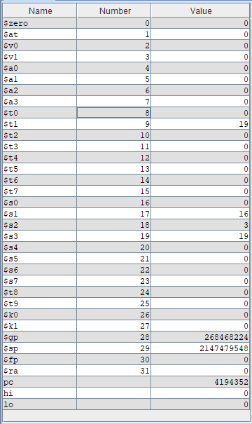

=> $t0 = 0 => không xảy ra tràn số.

* $s1 = 2147483647, $s2 = 3:

#Laboratory Exercise 4, Assignment 1

.text

start:

addi $s1,$zero,2147483647

addi $s2,$zero,3

li $t0,0 #No Overflow is default status

addu $s3,$s1,$s2 # s3 = s1 + s2

xor $t1,$s1,$s2 #Test if $s1 and $s2 have the same sign

bltz $t1,EXIT #If not, exit

slt $t2,$s3,$s1

bltz $s1,NEGATIVE #Test if $s1 and $s2 is negative?

beq $t2,$zero,EXIT #s1 and $s2 are positive

# if $s3 > $s1 then the result is not overflow

j OVERFLOW

NEGATIVE:

bne $t2,$zero,EXIT #s1 and $s2 are negative

# if $s3 < $s1 then the result is not overflow

OVERFLOW:

li $t0,1 #the result is overflow

EXIT:

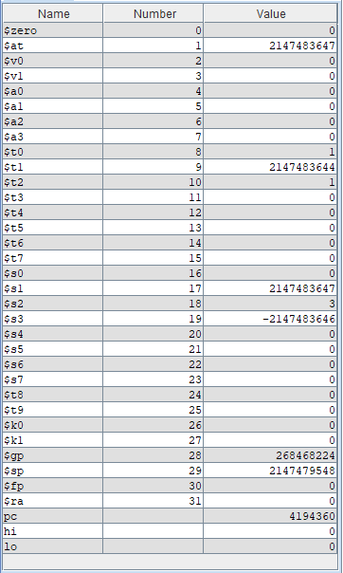

=> $t0 = 1 => xảy ra tràn số

* $s1 = -16, $s2 = 3:

#Laboratory Exercise 4, Assignment 1

.text

start:

addi $s1,$zero,-16

addi $s2,$zero,3

li $t0,0 #No Overflow is default status

addu $s3,$s1,$s2 # s3 = s1 + s2

xor $t1,$s1,$s2 #Test if $s1 and $s2 have the same sign

bltz $t1,EXIT #If not, exit

slt $t2,$s3,$s1

bltz $s1,NEGATIVE #Test if $s1 and $s2 is negative?

beq $t2,$zero,EXIT #s1 and $s2 are positive

# if $s3 > $s1 then the result is not overflow

j OVERFLOW

NEGATIVE:

bne $t2,$zero,EXIT #s1 and $s2 are negative

# if $s3 < $s1 then the result is not overflow

OVERFLOW:

li $t0,1 #the result is overflow

EXIT:

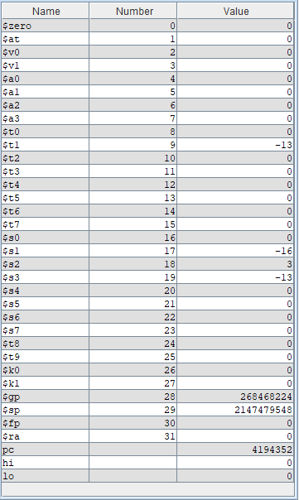

=> $t0 = 0 => không xảy ra tràn số.

Assignment 2

#Laboratory Exercise 4, Assignment 2

.text

li $s0, 0x12345678 #load 0x12345678 vào $s0

andi $t0,$s0,0xff000000 #Extract MSB of $s0

srl $t0,$t0,24

andi $t1,$s0,0xffffff00 #Clear LSB of $s0

ori $t2,$s0,0x000000ff #Set LSB of $s0

andi $s0,$s0, 0 #Clear $s0

* Extract MSB of $s0:

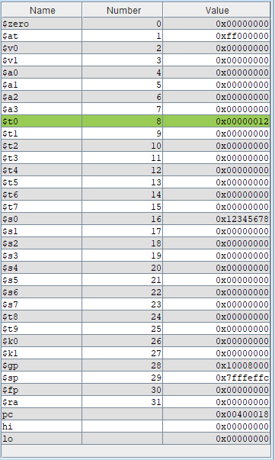

Lấy and của $s0 với 0xff000000 lấy được MSB của $s0 rồi dịch trái 6 bit vào thanh ghi $t0.

* Clear LSB of $s0:

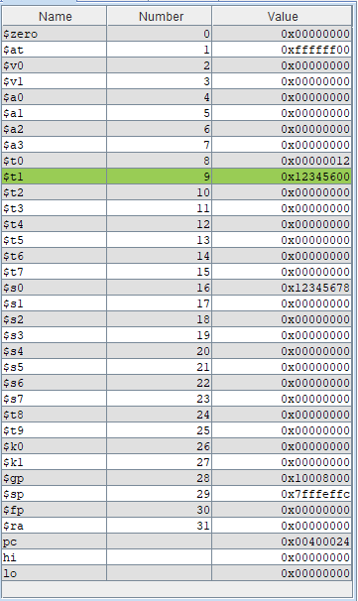

Lấy and của $s0 với 0xffffff00 sẽ xóa được LSB của $s0.

* Set LSB of $s0:

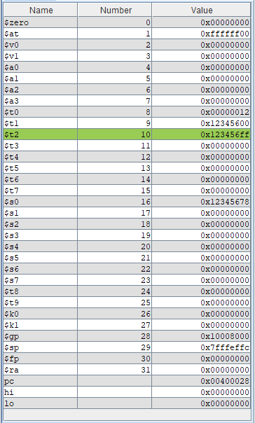

Lấy or của $s0 với 0x000000ff sẽ set được LSB của $s0 thành ff.

* Clear $s0:

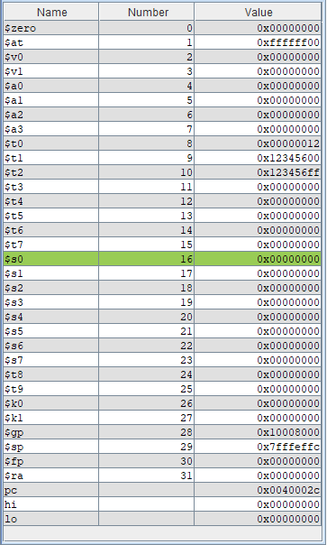

Lấy and của $s0 với 0 để clear toàn bộ bits của $s0.

Assignment 3

1. abs $s0,$s1 $s0 <= | $s1 |

#Laboratory Exercise 4, Assignment 3a

.text

addi $s1,$zero,-16

slt $t0,$s1,$zero

bne $t0,$zero,absoulute

j load

absoulute:

sub $s0,$zero,$s1

j end

load:

addi $s0,$s1,0

end:

1. move $s0,$s1 $s0 <= $s1

#Laboratory Exercise 4, Assignment 3b

.text

addi $s1,$zero,-16

add $s0, $zero, $s1

1. not $s0, $s1 $s0 <= bit invert ($s1)

#Laboratory Exercise 4, Assignment 3c

.text

addi $s1,$zero,-16

nor $s0,$s0,$s1

1. ble $s1,$s2,label if ($s1 <= $s2) j label

#Laboratory Exercise 4, Assignment 3d

.text

slt $at, $s2, $s1

beq $at, $zero, label

Assignment 4

#Laboratory Exercise 4, Assignment 4

.text

start:

li $t0,0 #Ket qua $t0 = 0 neu khong tran so

li $s1, 2147483647

li $s2, 3

addu $s3, $s1, $s2 # s3 = s1 + s2

xor $t1, $s1, $s2 #Kiem tra xem $s1 va $s2 co cung dau khong

bltz $t1, EXIT #Neu $t1 < 0, exit

xor $t2, $s3, $s1 #Kiem tra xem $s1 va $s3 co cung dau khong

bgtz $t2, EXIT #Neu $t2 > 0, exit

j OVERFLOW

OVERFLOW:

li $t0,1 #Neu tran so, ket qua $t0 = 1

EXIT:

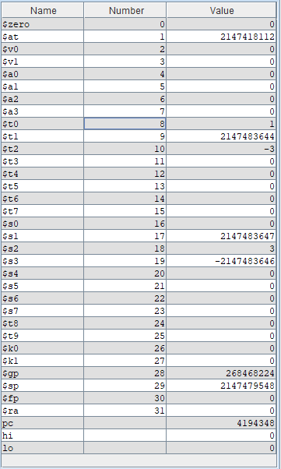

Assignment 5

#Laboratory Exercise 4, Assignment 5

.text

addi $s0, $zero, 3 #Dua so hang vao $s0

addi $s1, $zero, 16 #Dua thua so vao $s1

addi $t0, $zero, 1 #Cai dat $t0 co gia tri 1

loop:

beq $s1, $t0, exit #Neu $s1 chi con gia tri la 1 thi ket thuc vong lap

sll $s0, $s0, 1 #Tang gia tri $s0 len 2 lan

srl $s1, $s1, 1 #Giam gia tri $s1 di 2 lan

j loop #Lap lai

exit:

add $t9, $zero, $s0 #Luu ket qua vao $t9

